|  |  |
| --- | --- |
| Team ID | PNT2022TMID36999 |
| Project name | Containment Zone Alerting Application |

REGISTARTION PAGE

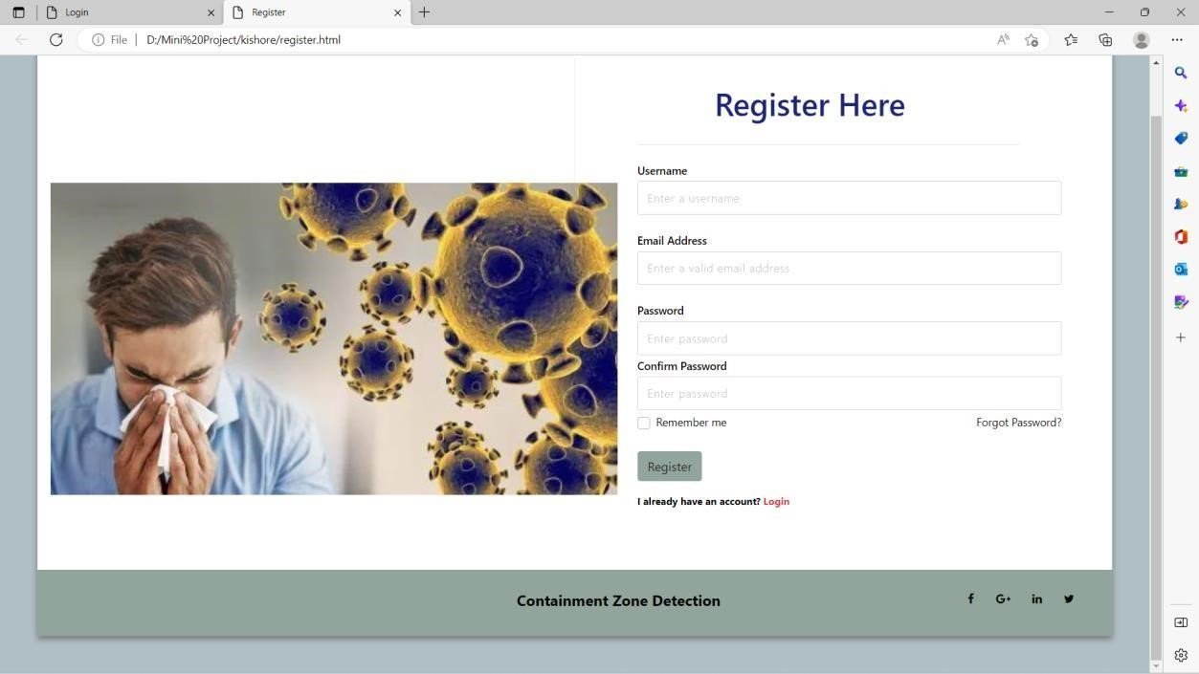

LOGIN PAGE

